Trigonometric Functions - Questions
June 2017 Mathematics Advanced Paper 1: Pure Mathematics 3

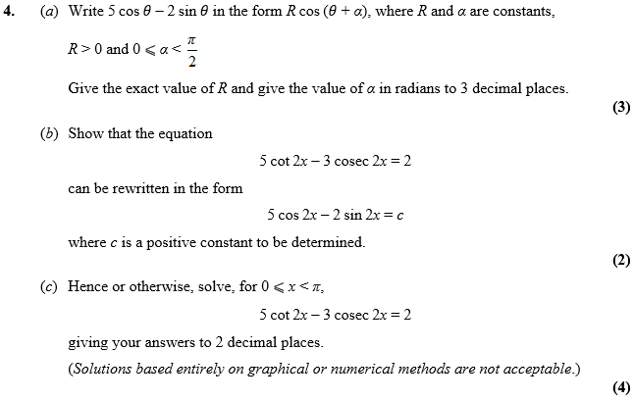

June 2016 Mathematics Advanced Paper 1: Pure Mathematics 3

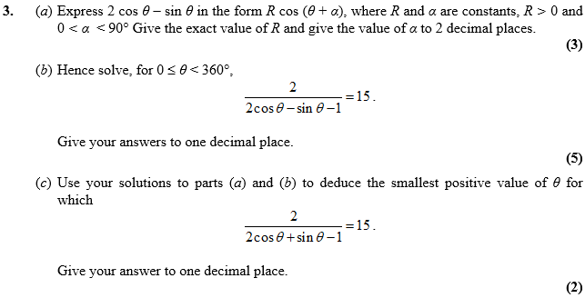

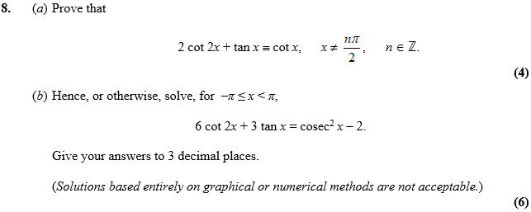

June 2015 Mathematics Advanced Paper 1: Pure Mathematics 3

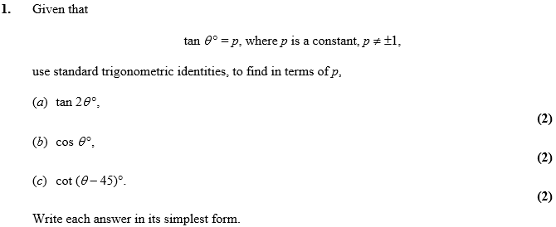

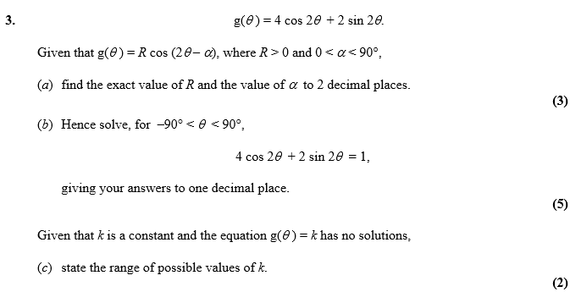

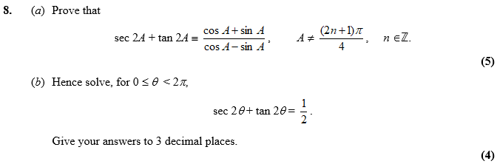

June 2014 Mathematics Advanced Paper 1: Pure Mathematics 3

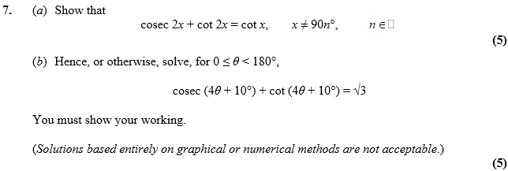

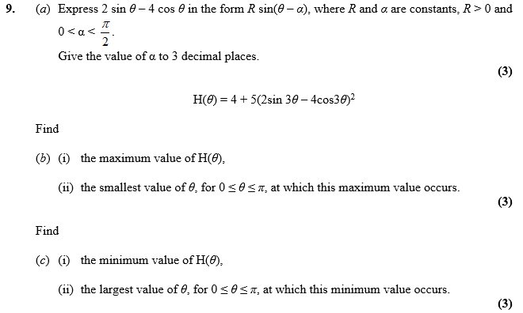

June 2013 Mathematics Advanced Paper 1: Pure Mathematics 3

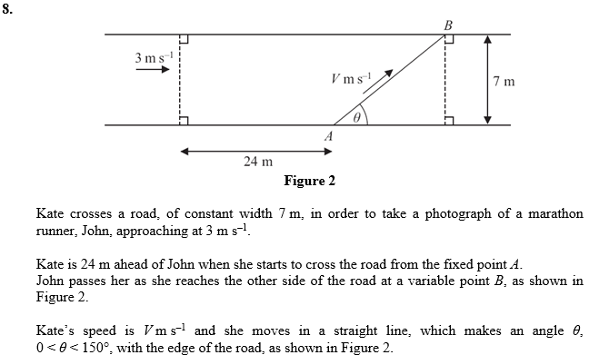
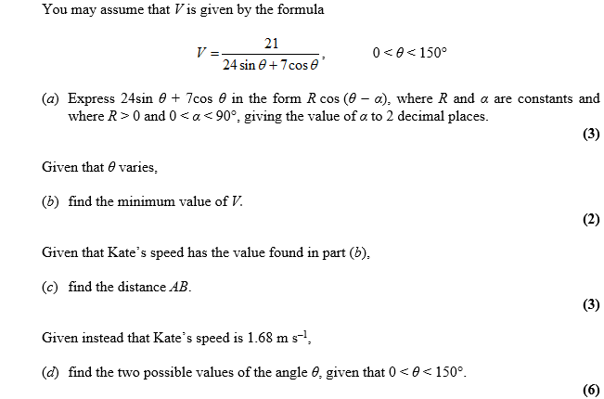

Jan 2013 Mathematics Advanced Paper 1: Pure Mathematics 3

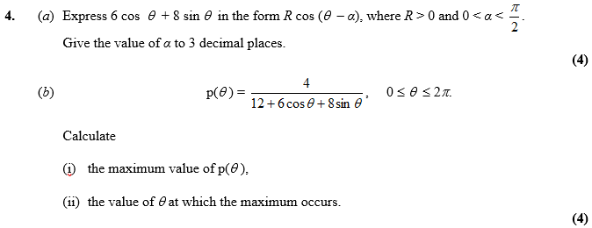

June 2012 Mathematics Advanced Paper 1: Pure Mathematics 3

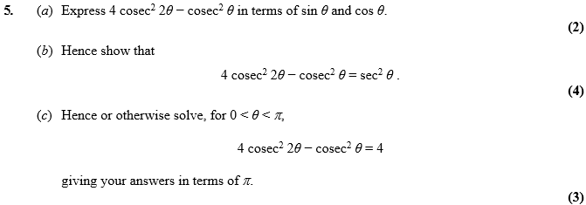

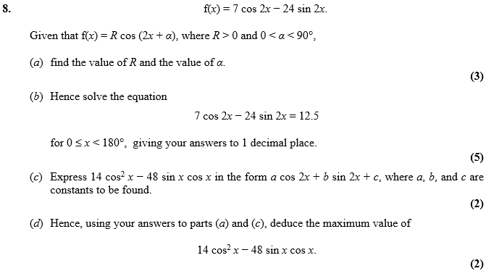

Jan 2012 Mathematics Advanced Paper 1: Pure Mathematics 3

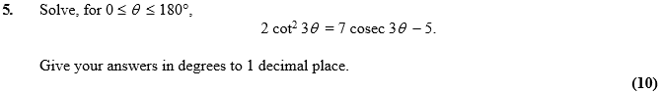

June 2011 Mathematics Advanced Paper 1: Pure Mathematics 3

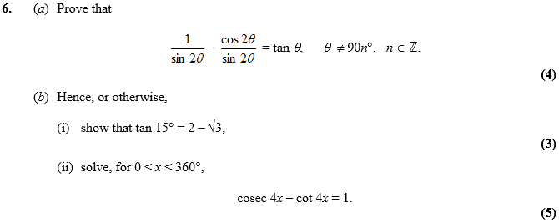

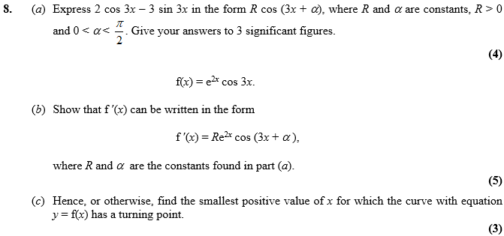

Jan 2011 Mathematics Advanced Paper 1: Pure Mathematics 3

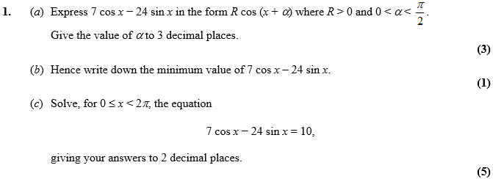

June 2010 Mathematics Advanced Paper 1: Pure Mathematics 3

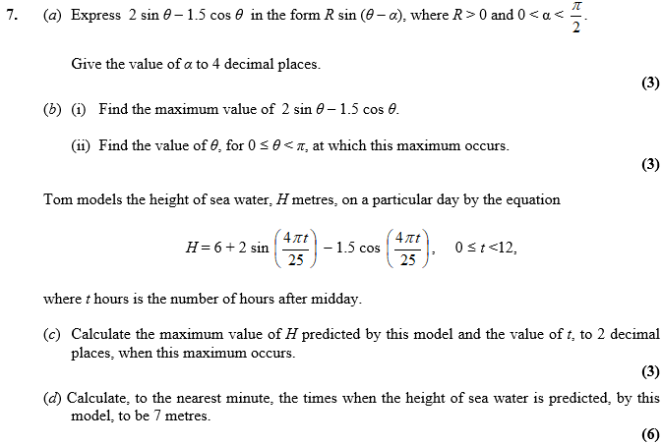

Jan 2010 Mathematics Advanced Paper 1: Pure Mathematics 3

